**Design Patterns**

1. Behavioural Patterns
   1. Strategy Pattern
   2. Observer Pattern
2. Strategy Pattern
   1. What?
      1. The Strategy Design Pattern defines a family of algorithms, encapsulates each one, and makes them interchangeable, allowing clients to switch algorithms dynamically without altering the code structure.
   2. Example
      1. Let’s consider a sorting application where we need to sort a list of integers. However, the sorting algorithm to be used may vary depending on factors such as the size of the list and the desired performance characteristics.

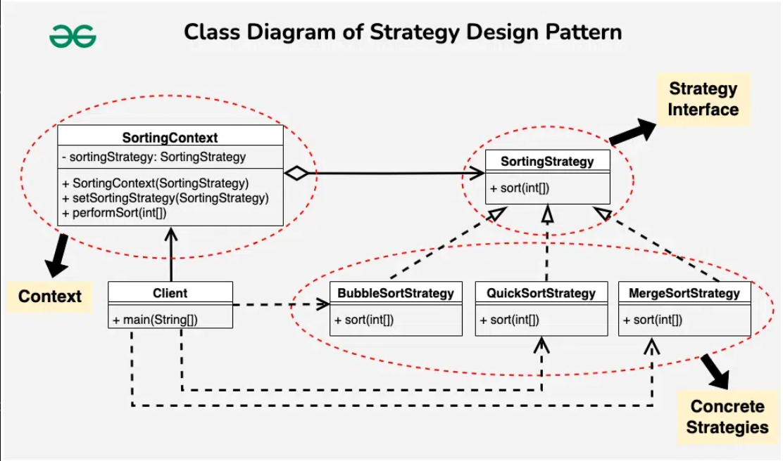

1. Observer Pattern
   1. What?
      1. The Observer Design Pattern is a behavioral design pattern that defines a one-to-many dependency between objects so that when one object (the subject) changes state, all its dependents (observers) are notified and updated automatically.
   2. Example
      1. Let us Imagine a scenario where the weather station is observed by various smart devices. The weather station maintains a list of registered devices. When there’s a change in weather conditions, the weather station notifies all devices about the update.

